Engineering Docs - Deal Flow (Opty & CPQ)

Overview

The Quote to Oder process describes end to end sales process where a sales representative can make an offer to a prospective customer for a certain product. Prospective customers will have a room to negotiate and make a decision. For information about the complete user journey from Quote to Order for different sales levers, refer to the presentation.

What does it do?

Create quote

Configure Quote

Configure Quote for End client Discount

Configure Quote for Tiered Discount

Configure quote for Tiered By Message Type Discount

**Who uses it and when?**

|  |  |  |
| --- | --- | --- |
| **Persona** | **Responsibilities** | **Capability** |
| **Sales Representative/Sellers (Account Executives for Direct Sales and Client Partner for GBG Team )** | * Sourcing new business for Meta * Engaging potential customers on Meta products and managing deal cycle end-to-end | * Create Quote for end client * Edit and update quote as per customer negotiation * Create offer and apply discounts * Apply discounts for partners |
| **Partner Manager** | * Assisting the Partner ecosystem | * Edit and update quote as per partner request * Create offers and apply discounts for partner negotiated deals |
| **Partner/BSP** | * Sourcing new business deals * Managing and converting leads passed on by Meta * Act as solution providers partner to end clients | * Create quote for end client via partner portal * Edit and update quote as per customer negotiation * Will not be creating offer |
| **Price Ops – Approver** | * Determining and validating pricing and discounting structure for standard and Tiered Discounts deals | * Work with sales reps for custom contracts |
| **Legal – Approver** | * Creating custom contract terms & conditions | * Collaborate with pricing ops for custom contracts (seems like this should be in the role column). |
| **Sales Ops** | * Helping with sales rep with operational task associated with the quote | * Edit quote for end customer * Not able to initiate a quote |

Deal Collaboration Approach for Partners

The portal brings a more standardized approach to pipeline management.

The partners create or upload their deals on the portal. After a deal is qualified, add qualification information on the deal, and submit the deal for review.

The deal will be reviewed for data quality and will then be converted to an opportunity automatically. After conversion of the deal to opportunity, you will see them under the opportunity tab and can progress them along stages.

Partners update the portal on a weekly basis.

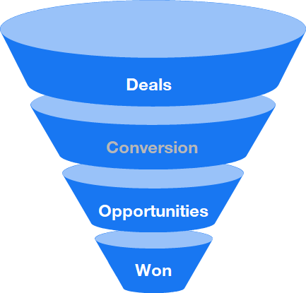

MDF Fund Applications and Claims

Eligible partners can submit MDF requests and claims via the Partner Portal. A fund request is an application for funds to subsidize qualifying co-marketing activities and are subject to Meta approval. Requests can be submitted during the applicable window only, as indicated in the notification banner, and by invitation from your Partner Manager.

Fund Claim

After Meta approves the claimed fund requests, partners can MDF claims via the Partner Portal. A fund claim is an amount requested to be reimbursed against an approved fund request for marketing activities executed during the period. Claims can be submitted during the applicable window only, as indicated in the notification banner, and after the campaign has been conducted in the market. To submit a new MDF claim, there are two options to select.